38.79: a) The period was found in Exercise 38.27b: 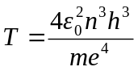 and frequency is just
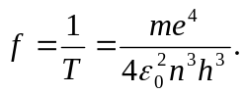
b) Eq. (38.6) tells us that 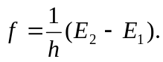 So 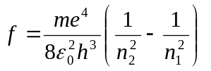 (from Eq. (38.18)).
If 